**Project Design Phase-II**

**Data Flow Diagram & User Stories**

|  |  |
| --- | --- |
| Date | 27 June 2025 |
| Team ID | LTVIP2025TMID41423 |
| Project Name | Pattern Sense: Classifying Fabric Patterns using Deep Learning |
| Maximum Marks | 4 Marks |

**Data Flow Diagrams:**

A Data Flow Diagram (DFD) is a traditional visual representation of the information flows within a system. A neat and clear DFD can depict the right amount of the system requirement graphically. It shows how data enters and leaves the system, what changes the information, and where data is stored.

**Flow Diagram:**

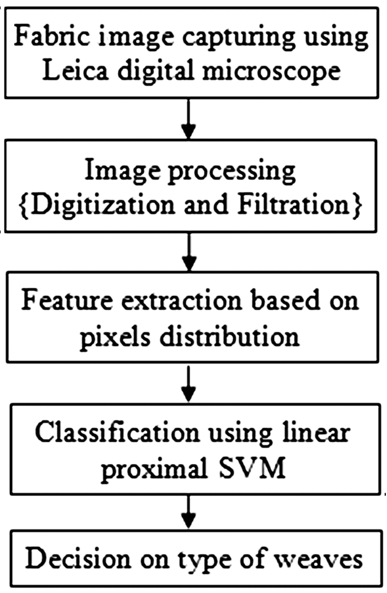

**User Stories**

Use the below template to list all the user stories for the product.

| **User Type** | **Functional Requirement (Epic)** | **User Story Number** | **User Story / Task** | **Acceptance criteria** | **Priority** | **Release** |
| --- | --- | --- | --- | --- | --- | --- |
| Admin / Developer | Dataset & Preprocessing | USN-1 | As a developer, I want to upload and preprocess fabric images so the model receives clean, normalized data. | Images are resized, augmented, and stored in the correct format. | High | Sprint-1 |
|  | Define Pattern Categories | USN-2 | As a researcher, I want to define and standardize fabric pattern categories for consistent labelling.. | A finalized list of labels is available and used across dataset and model training. | High | Sprint-1 |
| System | Image Classification Model | USN-3 | As a system, I need to classify fabric patterns using a CNN model and return the top prediction with confidence. | Model provides output within acceptable accuracy threshold (e.g., >85%) and includes confidence score. | High | Sprint-2 |
|  | Model Training & Evaluation | USN-4 | As a developer, I want to train the model using the prepared dataset and evaluate it using validation/test splits. | Model is trained, tested, and evaluation metrics (accuracy, F1-score) are documented | Low | Sprint-3 |